

|  |
| --- |
| Billing System - Demonstration |
| July 29, 2015 |

Green document, no print out please



|  |
| --- |
| Internal |
| Krishanu Chakraborty |

#### Contents

Billing System – Sample Screenshots and Navigation 3

Remarks 5

# Billing System – Sample Screenshots and Navigation

1. 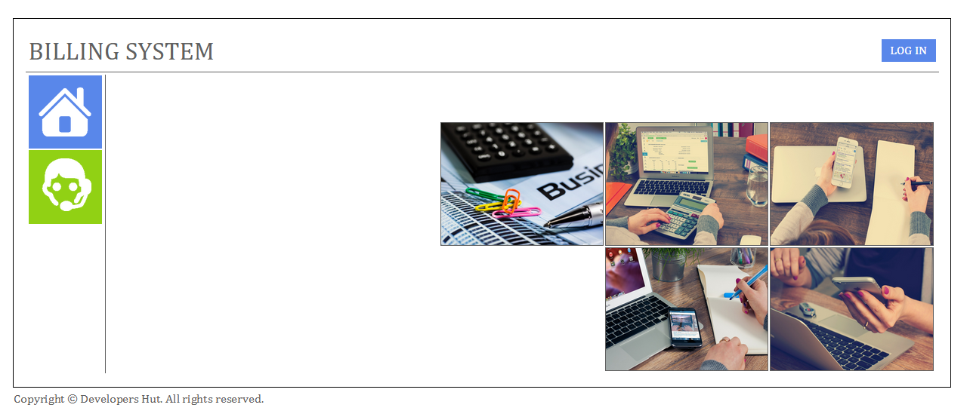**Home Page** will be displayed during the start of application which will be accessed by a web URL:
2. 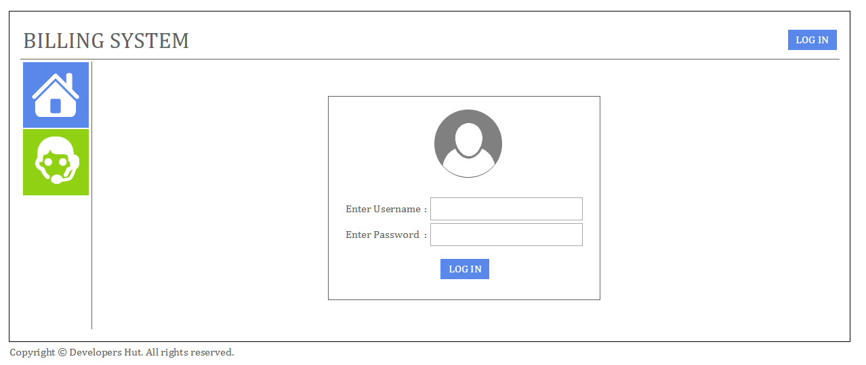By Clicking on **LOGIN** button, login page will appear as follows:
3. Blue **HOME** button  will redirect the user to the application homepage if user is not logged in to the system.
4. Green **TECHNICAL SUPPORT** will redirect the user to the contact details for the concerned technical person as shown follows:

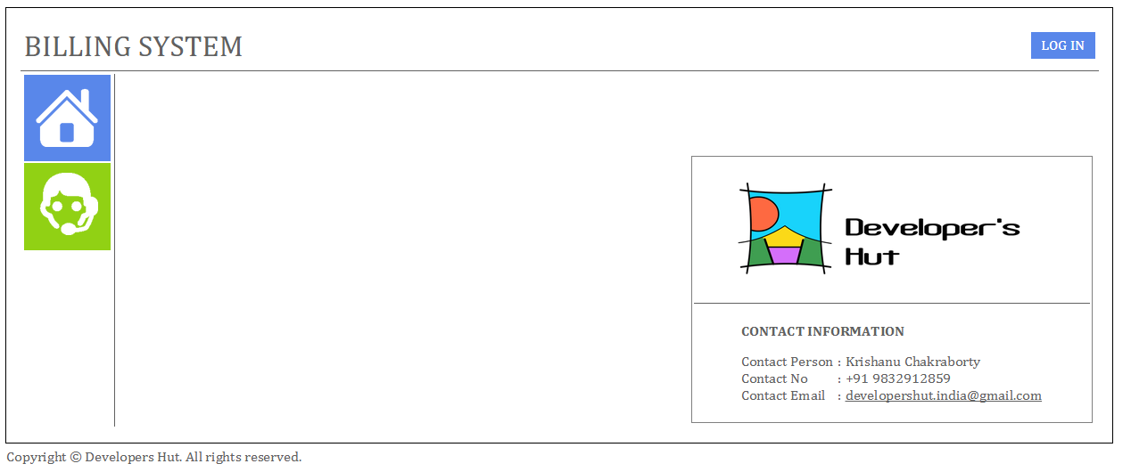

1. After login to the application, user will get the home page as follows:
2. 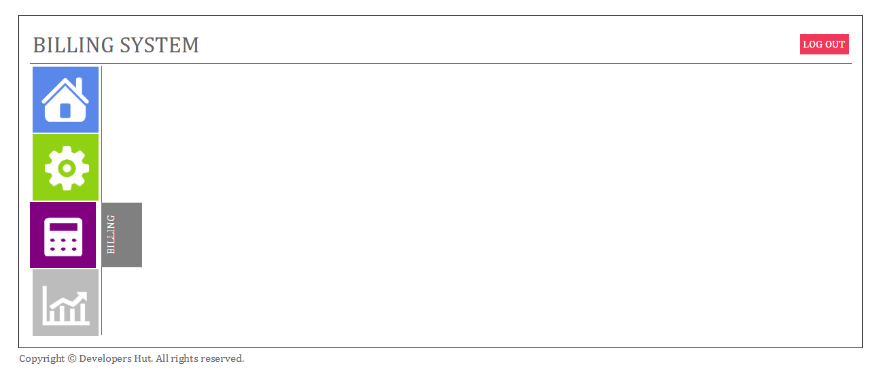The buttons on the home page after user login will be with following functionality:

 User home page with user specific reports

 Settings to setup new users, roles and password reset

 Billing – Invoice, Invoice PDF generation, print invoice

 Reports – To get invoice details, total amount, total VAT calculation etc.

# Remarks

Please be informed that the application is under development as per the requirement you have mentioned. We will keep you updated with the progress and demos periodically.